A taste of The Catechesis of The Good Shepherd
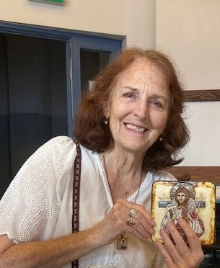
Rebekah Rojcewicz has Montessori certification and has been a catechist and formation leader in the Catechesis of the Good Shepherd since completing her training program with its founders, Dr. Sofia Cavalletti and Prof. Gianna Gobbi in Rome in 1981. She has translated several of their books and articles from the original Italian and has written various pieces of CGS core texts, as well as her own book about the catechesis: Life in the Vine. Rebekah works with children ages 3-12 at St. Patrick’s Catholic Church in Memphis, Tennessee and at the atria of the Missionaries of Charity. She serves on the formation advisory council of CGSUSA, as well as on the International Board of the Catechesis of the Good Shepherd.
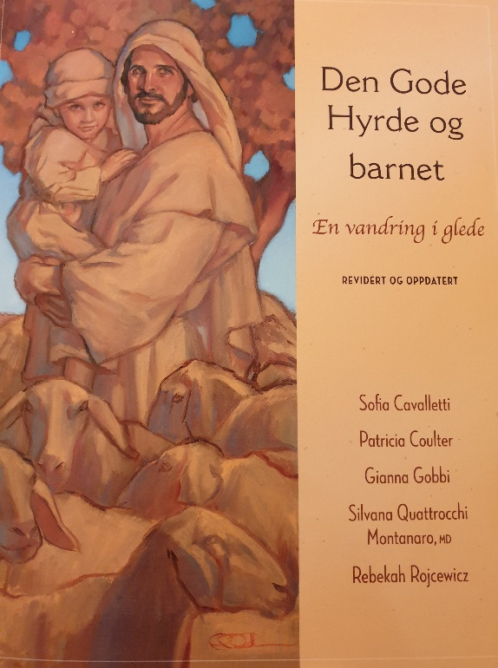
Saturday, the 25th of April at 4 p.m – 6 p.m:
“The essence and richness of The Catechesis of The Good Shepherd.
Sunday, the 26th of April at 12 – 1 p.m:
“Formation for the new family – parents and their 0-3 children”
Marias Minde, Nylandsveien 31.
Due to reserving of room, please sign up for this free events by email: reidun.jofrid.kleppestrand@katolsk.no

