The Catechesis of The Good Shepherd
introductory formation course on
serving infants, toddlers and their parents
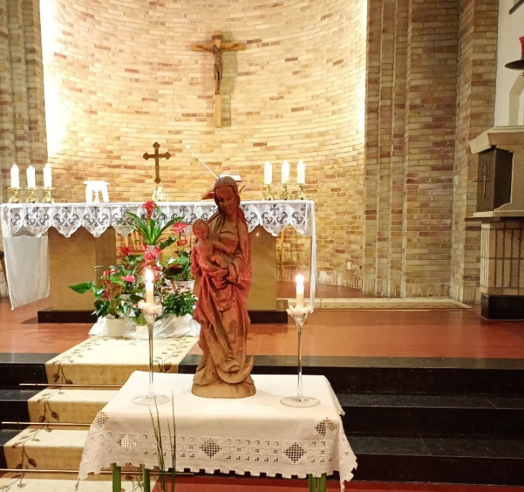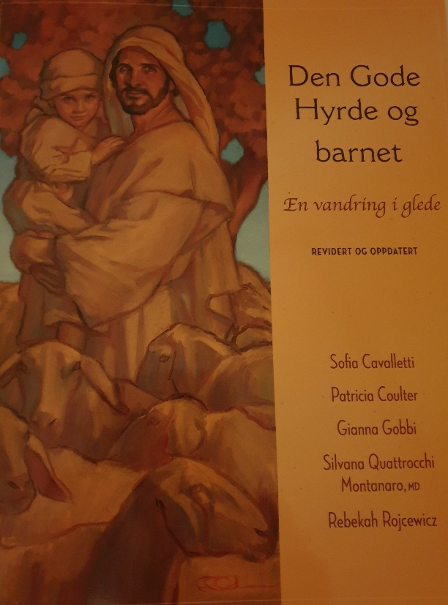
Sunday 26th of April (starting with Mass at 10 a.m) – Friday 1st of May.
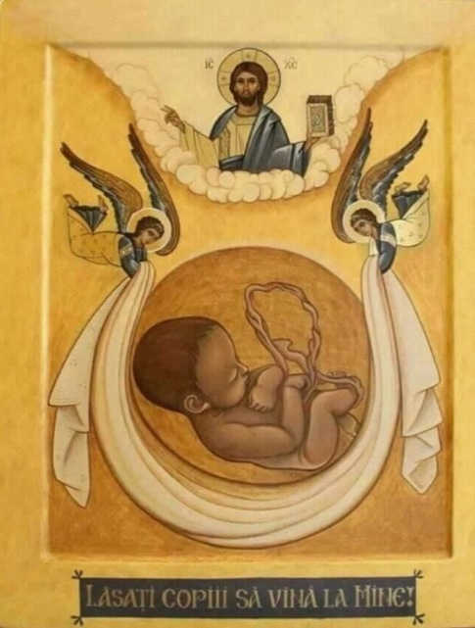
Every day 09 a.m – 5 p.m, daily Mass and breaks included. If you would like to join, you have to sign up by email to: reidun.jofrid.kleppestrand@katolsk.no Further registration details will then be given.
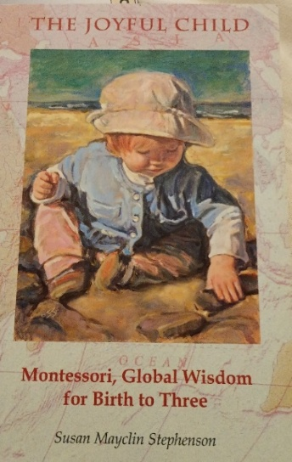
It is expected that you join the whole retreat, not only come for parts of it.
Marias Minde, Nylandsveien 31.
Among the themes will be:
The development of the youngest child,
the environments of the womb and the home,
the beginnings of“Mommy and Me”, the preparation of the adult and the sacrament of Baptism.

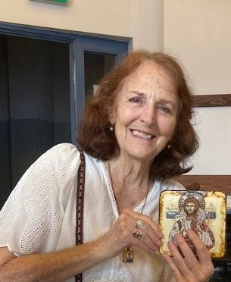
Rebekah Rojcewicz has Montessori certification and has been a catechist and formation leader in the Catechesis of the Good Shepherd since completing her training program with its founders, Dr. Sofia Cavalletti and Prof. Gianna Gobbi in Rome in 1981. She has translated several of their books and articles from the original Italian and has written various pieces of CGS core texts, as well as her own book about the catechesis: Life in the Vine. Rebekah works with children ages 3-12 at St. Patrick’s Catholic Church in Memphis, Tennessee and at the atria of the Missionaries of Charity. She serves on the formation advisory council of CGSUSA, as well as on the International Board of the Catechesis of the Good Shepherd.

